EEE-6512 Image Processing and Computer Vision

Fall 2020 Homework #3

September 24, 2020

**Due: October 10, 2020, 11:59 PM**

This assignment should be completed individually by the student. Late submissions will not be accepted. Proper citation should be provided for any references used.

**Part I Textbook Questions [50 points]**

Answer the following questions adapted from the textbook:

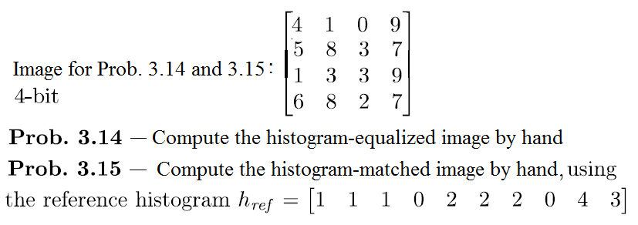





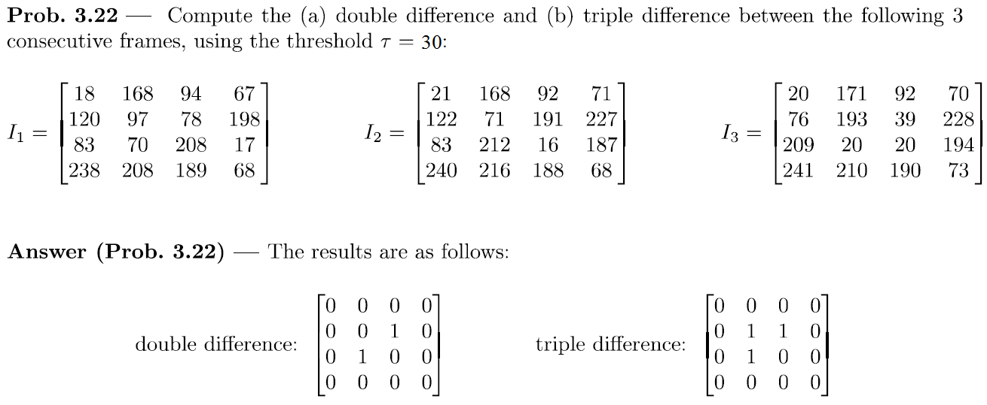



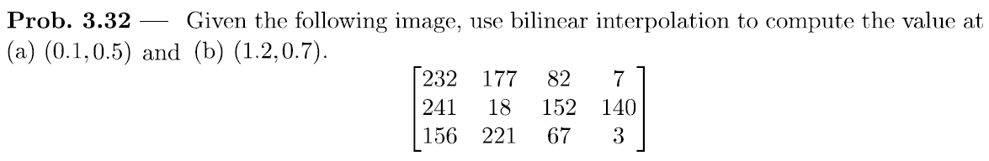



**Part II MATLAB Programming [50 points]**

Please read requirements carefully. Solutions that do not follow provided specifications will not receive credit. **Explain all code in the writeup and include all citations used to develop the code (e.g. books, websites, help forums, wikis, code found online, etc.).**

You are to write a program *background_sub* which operates in the following manner:

* Accept a video as input
* Convert the first 100 frames of the videoto grayscale using one of the conversion methods discussed in the text.
* Using the converted frames, compute the average image as described in the text.
* Display the average image. **Include this image in your writeup. Note: all images included in the writeup must be titled.**
* Choose at least five distinct frames from the grayscale videoand display the thresholded result of performing background subtraction on the five (or more) frames using the average image. (You are free to choose the threshold value.) **Include these five (or more) images in your writeup. Explain your results. Where does your algorithm perform well and where does it perform poorly? Why?**

You may use built-in MATLAB functions to read/write/display the video/image files only. A video file, *PeopleWalking.mp4*, has been provided to test your function.

To receive full credit for this assignment, you should submit three files. 1.) A document containing answers to the textbook questions, an explanation of your code, the average image, and the five (or more) thresholded background subtraction results and analysis (.DOC, .DOCX, or PDF file) 2.) An M-file containing commented MATLAB code for the program *background_sub*. Students should ensure that their M-files execute without errors to avoid receiving point deductions.